Circuit diagram

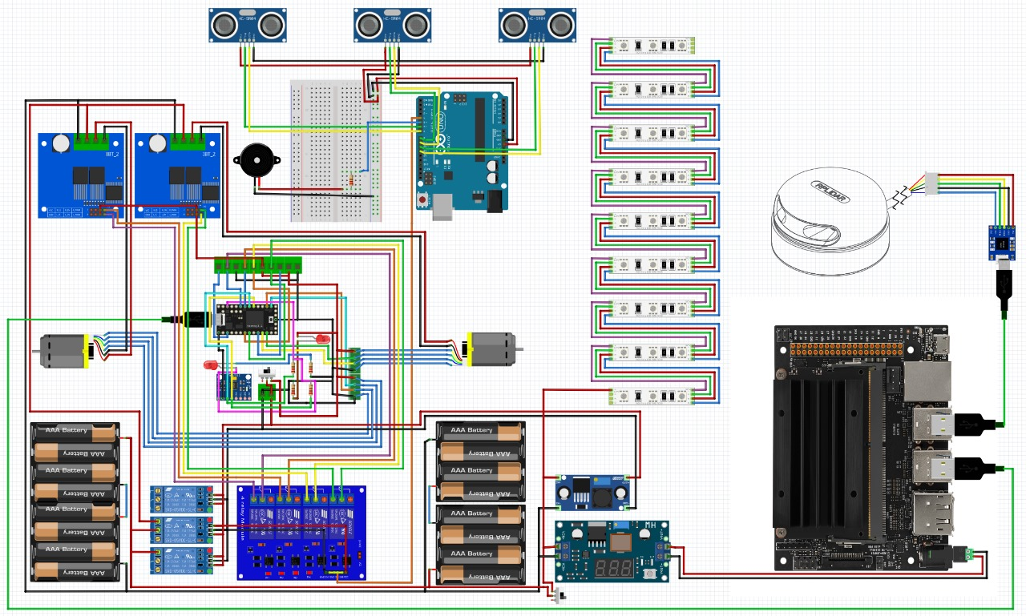

Nodes and Topics diagram

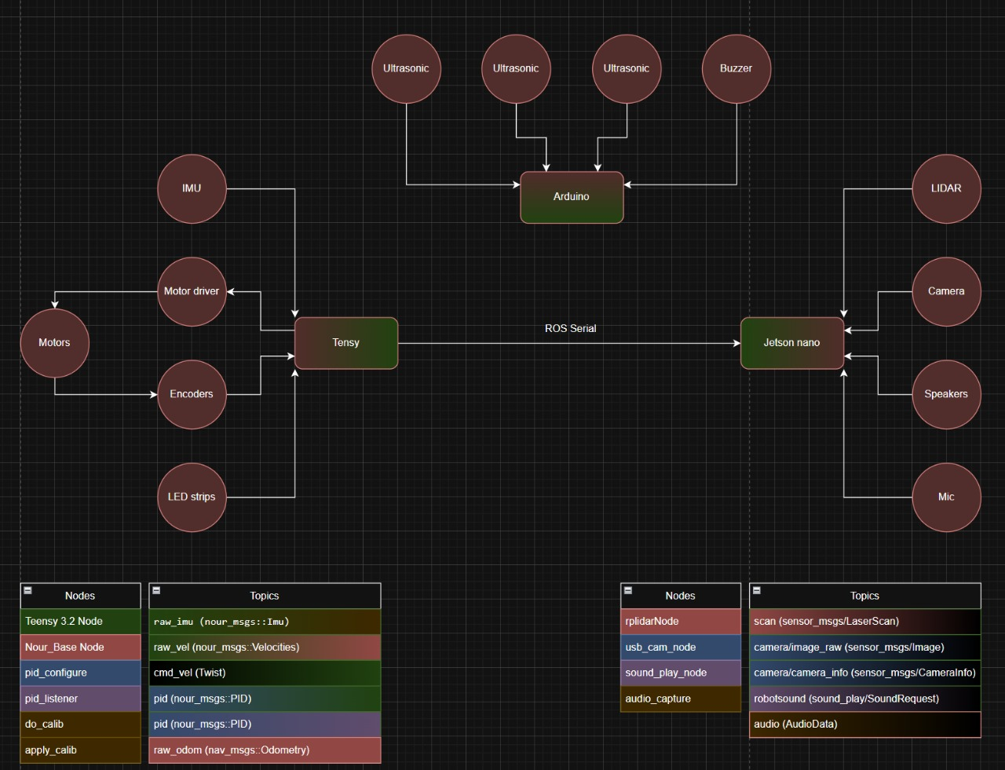

The nodes table specify the nodes names and the topics table specify the topics names in this format [ topic_name (msg_name) ]

Each node have a color
And each topic have two colors one for the publishing node (left color) and one for the receiving node (right color)

🔧 Hardware Overview

🔹 Microcontrollers & SBCs:
- Teensy (3.2): Controls core robot hardware (motors, encoders, IMU, LED strips)
- Arduino: Handles ultrasonic sensors and buzzer
- Jetson Nano: Main processing hub running ROS, connects everything together

🔹 Peripherals Connected to Each Unit:

Teensy
- Motors (through motor driver)
- Encoders
- IMU
- LED strips

Arduino
- 3× Ultrasonic sensors
- Buzzer

Jetson Nano
- LIDAR
- Camera
- Speakers
- Mic

🔁 Communication
- ROS Serial between Teensy/Arduino → Jetson Nano

Single Button Boot
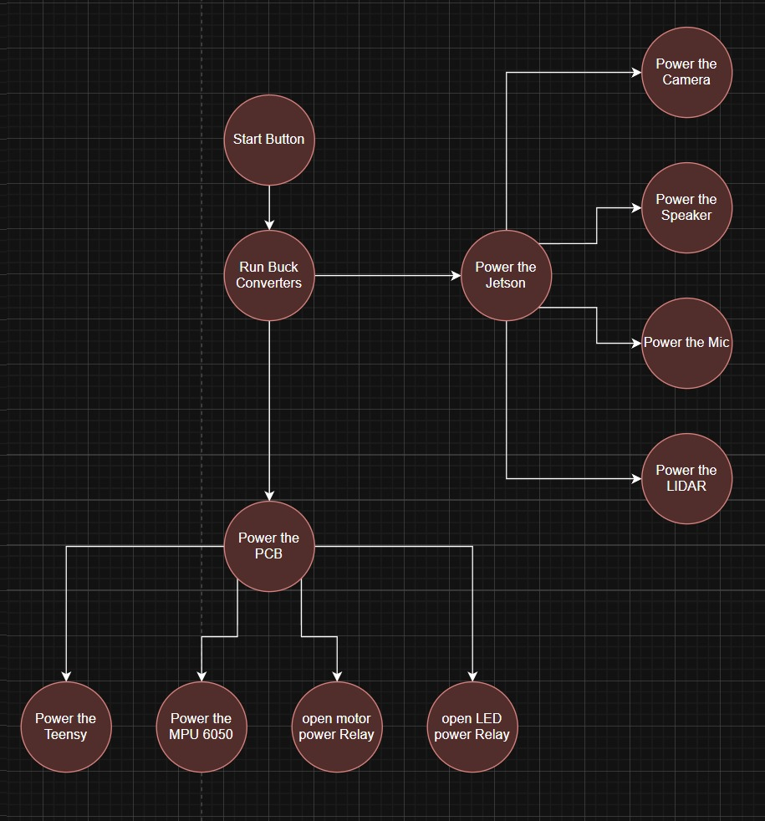

This is a power management flow diagram for a robotic system that uses a single Start Button to intelligently boot up all hardware components in a sequenced and controlled manner. Here's a breakdown:

🔘 Startup Sequence (Single Button Boot)

1. Start Button Pressed
- User triggers the system by pressing one button.

2. Run Buck Converters
- Buck converters step down voltage from the main power source to appropriate levels (e.g., 12V to 5V/3.3V).
- This is the first step in distributing power.

⚡ Parallel Power Distribution

🔷 Branch 1: Jetson Nano & High-Level Peripherals
- Power the Jetson Nano
  - This also powers:
    - Camera
    - Speaker
    - Mic
    - LiDAR
These are high-power components, usually powered via USB or dedicated regulators from the Jetson side.

🔷 Branch 2: PCB & Core Control System
- Power the PCB
  - Activates control electronics, including:
    - Teensy (controls motors, encoders, LED, etc.)
    - MPU6050 (IMU)
    - Motor Power Relay
    - LED Power Relay
This lets you individually switch on high-current components like motors and LED strips via relays, giving better power safety and control.

Motor Driver Replacement
To address the failure in our previous motor driver, we replaced the damaged component with two new motor driver units. This decision allowed us to balance current loads across the drivers, enhancing both performance and reliability. The new configuration supports higher current ratings.

Changes Implemented:
- Pin Reassignment: The codebase was updated to accommodate the new dual driver layout, ensuring proper PWM and direction signal mapping.
- Code Refactor: Refactored motor control logic in the Teensy firmware to manage dual motor drivers consistently and avoid redundant operations.

Teensy Repair and Recovery
The system experienced frequent errors due to corrupted firmware and hardware on the Teensy microcontroller.

Steps Taken:
- Issue Detection: Fixed the Teensy hardware wiring problem
- Troubleshooting: we found the library that caused error while uploading the code
- Validation: system stability was restored and sustained over extended testing cycles.

PID Constants Optimization
Initial testing revealed the robot’s motion was unstable and oscillatory, traced to improper PID control parameters for motor speed regulation.

Tuning Process:
- Conducted systematic tuning of Kp (Proportional), Ki (Integral), and Kd (Derivative) values using test ramps and step inputs.
- Final values achieved a good balance between responsiveness and stability, minimizing oscillation and improving tracking.

Project Achievements and Next Steps
With our hardware and control systems stabilized, we reached 90% completion of our intended functionality. Future achievements include:
- Bluetooth-Enabled Speaker Integration: Successfully test speakers paired via Bluetooth dongle, adding voice feedback capability.
- RealSense Camera Setup: Power up and interface the RealSense depth camera, while handling its high power demand by adjusting power allocation.
- Microphone Integration: Mount and connect the microphone, test in various placements for optimal sound pickup, and validate data acquisition for potential sound-based triggers.

Arduino Emergency Stop System
To ensure safety and reliable obstacle detection, we addressed multiple issues affecting the Arduino-based emergency stop system. This system is crucial for triggering immediate motor shutdowns if obstacles are detected within unsafe proximity.

Issues Identified:
- Damaged Ultrasonic Sensors: ultrasonic units were no longer responsive.
- Power Supply Instability: The Arduino was inconsistently powered due to loose connections.
- Faulty Wiring: Signal lines were prone to noise and false readings.

Fixes and Enhancements:
- Sensor Replacement: Installed new, calibrated ultrasonic sensors to replace the damaged units.
- Wiring Overhaul: Cleaned up and secured all sensor signal and power lines using shorter, shielded cables where needed.
- Stable Power Source: The Arduino is now reliably powered from a dedicated 5V rail on the PCB with reverse polarity protection.
- Functional Testing: Conducted close-range and long-range detection tests. Verified emergency stop triggers using test objects and dynamic robot scenarios.
The system now reliably halts motor commands via interrupt signals sent to the Relayes when an obstacle is detected within the set threshold, significantly improving operational safety.

